**Neureka Challenge 2020 Seizure Detection Pipeline: Biomed Irregulars**

C. Chatzichristos, J. Dan, A.M. Narayanan, N. Seeuws, K. Vandecasteele

The seizure detection pipeline used in the Neureka Challenge 2020 uses a fusion of the “multi-view” U-Net neural networks (NNs)[1]. Each U-Net exploits a different “view” of the dataset. Three different U-Net neural networks were trained with different versions of the EEG data provided for the challenge. They are, namely, raw EEG data, the data preprocessed with multichannel wiener filters and the data preprocessed with the CNN of ICLabel[2] (plugin of EEGlab). A simple outline of the pipeline used in the challenge is given in Fig.1.   


*Fig 1: The seizure detection pipeline*

The outputs of the each UNet NN are in the form of probabilities of an EEG time sample being a seizure. The three different U-Net NN output probabilities are fused using an LSTM Recurrent Neural Network of two layers. Some simple rules are set as a postprocessing of the LSTM outcome (e.g seizures with length less than 15 seconds are not allowed).

*Fig 2: An example architecture of a U-Net NN used in the pipeline*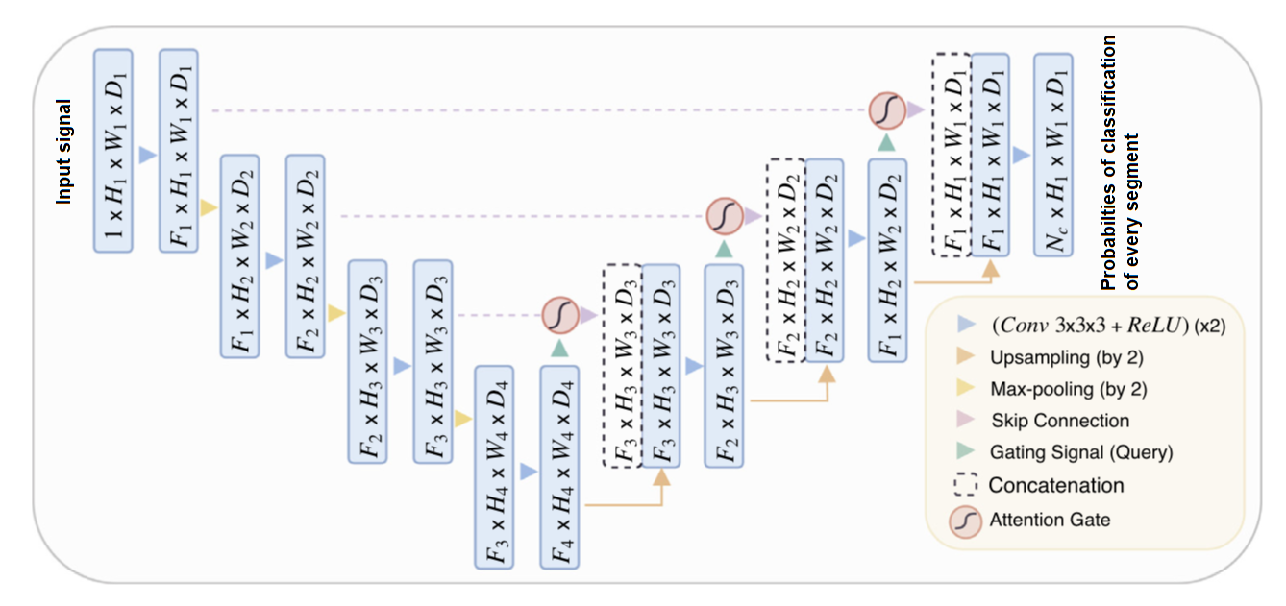

The U Net networks that were used are using attention layers as can be viewed in Fig 2.

The code used in the Neureka challenge is located in the following github repository:

<https://github.com/mabhijithn/irregulars-neureka-codebase>

The code used is separated in three different folders. Preprocessing, DNN and Post processing. In the irregulars-neureka-codebase/preprocessing folder, two separate subfolders exist; the code for multichannel wiener filtering and ICLabel is included in each separate folder. The main folder DNN includes the different U-Net networks, while the last folder irregulars-neureka-codebase/postprocessing includes the LSTM network used for fusion and also the postprocessing rules set. All the code is written in Python, using Jupyter notebooks. Only the code for ICLabel preprocessing is written in MATLAB (since EEGLAB toolbox which implements CNN ICLabel toolbox is developed for MATLAB). In every folder a separate readme file is provided which helps in the execution of the code in different parts.

As perquisites for running the code are the following:

1. ICLABEL – EEGlab with plugins cleanrawdata, biosig, IClabel
2. DNN:
   1. pandas, numpy , matplotlib, h5py, scikit-learn, tensorflow (>=version 2.0)
3. Multi-channel wiener filtering and postprocessing (fusion and rules) :
   1. numpy, pyedflib, resampy, scipy, tensorflow (>=version 2.0), keras

**References:**[1] Schlemper, J., Oktay, O., Schaap, M., Heinrich, M., Kainz, B., Glocker, B., & Rueckert, D. (2019). “Attention gated networks: Learning to leverage salient regions in medical images” *Medical image analysis*, 53, 197-207.

[2] Luca Pion-Tonachini, Ken Kreutz-Delgado, Scott Makeig, “ICLabel: An automated electroencephalographic independent component classifier, dataset, and website” , NeuroImage, Volume 198, 2019, Pages 181-197, ISSN 1053-8119,

<https://doi.org/10.1016/j.neuroimage.2019.05.026>.